### **Prasath D - 212221020033**

### **EXP 7: Exploration of Prompting Techniques for Audio Generation**

#### **Aim:**

To explore various prompting techniques for generating audio using AI models. The goal is to understand how different types of prompts influence the generation of audio, such as music, sound effects, or speech, and how to optimize these prompts for specific needs.

#### **Procedure:**

1. **Understanding the Basics of Audio Generation with AI:**
   * Familiarize yourself with AI audio generation tools like **OpenAI’s Jukedeck**, **Google’s AudioLM**, or **other music generation models**.
   * These models take textual or musical prompts and produce sound outputs based on the input.
2. **Simple Prompt for Audio Generation:**
   * Start with basic text prompts to generate simple sounds or melodies.

**Example Prompt for Music Generation:**"Generate a calm and soothing background music for relaxation, in the style of classical piano music."

1. **Interactive Prompting with Customization:**
   * Test interactive techniques by generating parts of audio, then prompting the model for modifications or additions.
2. **Generating Speech or Voice:**
   * Explore prompting techniques to generate voice or speech, either for podcasts, announcements, or dialogue.
3. **Sound Effects Generation:**
   * Test the generation of specific sound effects like nature sounds, ambient sounds, or sound design for movies.
4. **Exploring Multimodal Inputs (Text + Music):**
   * Some advanced systems allow both text and sound input. Try combining text prompts with other musical references (e.g., links to existing music or sounds) to generate personalized audio.
5. **Optimizing Audio Prompts:**
   * As you experiment with various prompts, observe which elements are most important in influencing the quality and relevance of the generated audio.
   * Test different phrasing or additional context to see how the AI’s responses

#### 

#### **Instructions:**

1. **Choose an Audio Generation Tool:** Select a suitable AI-based audio generation tool (e.g., OpenAI’s Jukedeck, Google’s MusicLM, etc.).
2. **Create Basic and Advanced Prompts:** Start with basic prompts and gradually increase the complexity by adding more context and details.
3. **Experiment with Various Inputs:** Experiment with prompts for different audio types like music, sound effects, and speech.
4. **Listen to the Output:** After generating the audio, assess the quality and appropriateness of the output for the given prompt.
5. **Iterate and Optimize:** Modify the prompts to enhance the audio generation process, exploring what works best for your needs.

#### **Deliverables:**

1. **Set of Prompts:**

**Prompt: ‘**Give me some violin music’

**Refined prompt**: A more refined prompt includes specific details about the genre, instruments, mood, tempo, and duration. This helps the AI model generate more targeted results.

**Prompt**: ‘Create a serene and emotional violin solo, featuring smooth, flowing melodies with subtle dynamics. The piece should convey a mix of longing and hope, transitioning between soft, delicate passages and powerful, soaring sections. Incorporate a light orchestral background to enhance the richness of the violin, but ensure the solo remains the centerpiece.’

1. **Generated Audio Outputs:** <https://www.melodia.io/c/7f5e9e12-1013-47e9-aff8-a160f0bbdd89>

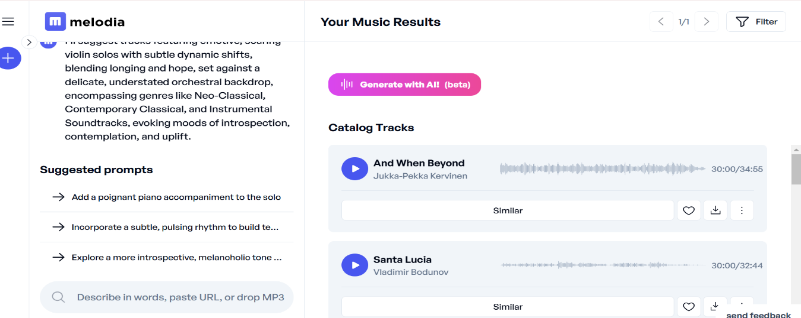

1. **Observations and Insights:** Notes on how different prompt designs affect the generated audio (e.g., clarity, mood, tempo, quality).
2. **Optimization Report:** A report summarizing the best prompting techniques for generating specific types of audio (e.g., music, sound effects).

#### **Conclusion:**

By experimenting with different prompting techniques for audio generation, we can see how AI can create diverse and tailored audio outputs based on simple or complex instructions. Starting with basic prompts and gradually adding more specific details leads to a more refined audio output, demonstrating the power and flexibility of AI tools in creative domains like music, sound design, and voice synthesis.